Day 6 tasks:

Session 1:

Walked through a simple Selenium automation script:

from selenium import webdriver

driver = webdriver.Chrome()

driver.get("https://qxf2.com/selenium-tutorial-main")

name = driver.find_element("xpath", "//input[@id='name']")# Find the name field and fill name

name.send_keys('Deekshitha')

driver.find_element("xpath","//input[@name='email']").send_keys('deekshitha@qxf2.com')# Find the email field and fill your email

phone = driver.find_element("id", "phone")# Find the phone no field and fill phone no

phone.send_keys('9999999999')

button = driver.find_element("xpath", "//button[text()='Click me!']")

button.click()# Identify the xpath for Click me button and click on it.

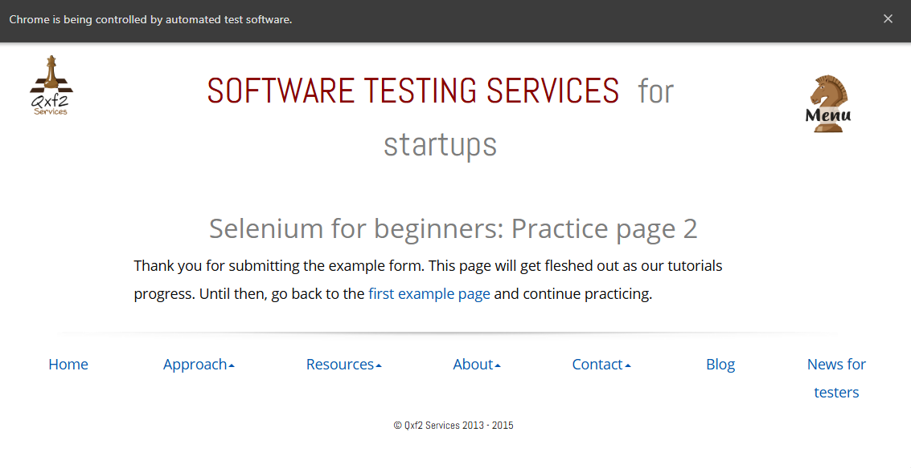

Session 2:

The model was trained to classify the tweets as positive or negative.

